
2026
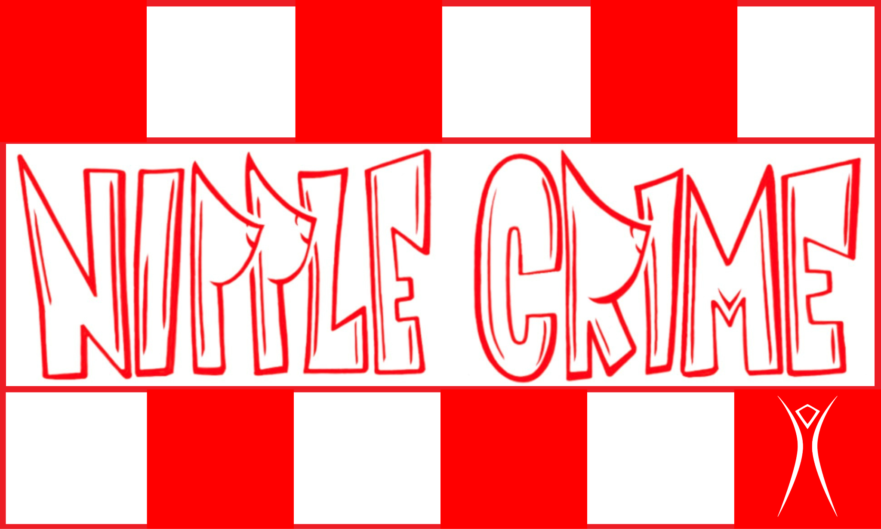
Art Car Supervisor Infrastructure

Anthony (TWØN) Tolosano

Chain of Command: Reports to the Infrastructure Director. Oversees Art Car Lead.
Job Description: The Art Car Supervisor is responsible for SirKiss to be mechanically sound, assembled, and ready for deployment at all times. This person will have complete knowledge of every system and can troubleshoot problems as they present. They will manage the schedule of Drivers and DJs and provide full training prior to deployment.

Responsibilities:
- Maintenance
  - Develop replacement parts inventory
  - Assemble necessary department tool kit
- System Management
  - Vehicle Chassis
  - Generator Power Grid
  - Sound System
  - Lighting
  - Shade Rooftop
  - Mister System
- Operation and Training
  - Driver and Spotter shifts
  - DJ Scheduling
- Housekeeping
  - Daily MOOPing
  - Post-playa cleanup

